THANK YOU JESUS CHRIST

Inbox

https://lh3.googleusercontent.com/a/ACg8ocIi0sD_-J-LCr_R6KhD386tAqdpyOphIJbYDj5hcGANagzGUZRE=s40-p

|  |  |  |  |  |  |  |
| --- | --- | --- | --- | --- | --- | --- |
| |  | | --- | | **Syed Ali Abbas Paul Eliya <eliyasyedaliabbaspaul@gmail.com>** | | | Attachments15:43 (2 minutes ago) | |  |  |
| |  | | --- | | to info, dacf, aileen.zhou, dg, complaint, director.admin, director.finance, director.estate, director.jv, director.law, director.coord, director.IT, director.technical, director.security, director.ia, director.planning, director.land, director.maintenance, director.revenue, director.jvkci, AD.AstonAndSuttonColdfield, AD.ColeshillAndPolesworth, AD.HandsworthAndCentral, AD.KNMS, Admin, Citizen, CPIinfoMali, Courrier, Fadi.El-Abdallah, Falak, FreeJobs, GENESIS, Info, JU, Mike.Sermon, Nick.Parker, OTP, OTPNewsDesk, Ohchr-dexrel, Ombudsman, Passport.london, Paul, Perfect, Procurement, Security, Here's, Sohaibchoudry221998, me, WaleedbinToufeeq, WeTrip, achats, administrator, agnes.eklund, agnes.jansson, ahmadiaportugal, alexandra.cederquist, amjmalta, andia.gemsjo, anna.erhardt, anna.lund, apdpftac2, applications, appt.london, atfal, attcons.washington, bilal.lodhi, bishop.david, bishopofaston, bishopsadmin, bookkeeping, caritas.internationalis, cee-office, ceo, com.tehran, com3.washington, commregen, comms, communications, cons.islamabad, cons.tehran, cons1.telaviv, cons2.telaviv, cons6.washington, consuly, contact, contact, contact, contactus, contatti, copyright, dave, dioceseoflondon, discipleship, donorcare, eastafritac, editor, education, elana, emergencies, enquiry, environment, farrakhmansoor, financeteam, flex, frezza, fsoci.washington, fspic.washington, fund, givingtogether, glavno.tajnistvo, hammad.tariq, helpdesk, helpdesk, helplinephc, hoc.babbas, hoc.tehran, hqepu, hr, hr, hrmartha, i.registrar, ieo, imam.ahmed, imffa, imfvideo, inclusiveandaccessible, info, info, info, info, info, info, info, info, info, info, info, info, info, info, info, info, info, info, information, information.hebrew, interculturalmission, interfaith, irnte, irnteprt, isaac.elm.communications, isbad, jennyt, ju.registrar, kancelaria, khuddamireland, kontakt, kontakt, kontakt, kpk, lahore, lahore\_churchcouncil, library, marriagebureau34, media, media, mineco.washington, ministry, mohsin.talpur, mubbbutt, muhammad.tariq, newchristiancommunities, ngoliaison, niazihaider786, obedarthur, office, office, ohchr-unvfvt, opinia\_ta, ouse, paivytys.um, panatz, parishmissionsupport, parishsurveyor, pathways, peopleandplaces, petrosillo, pniot, press, pressoffice, procurement, property, psamb.washington, psdcm.washington, publicaffairs, publications, reception, recrutement-recruitment, reehanashraf, refworld, revchris007, safeguardingsupport, sah, sanam.javed, sbs.malta.heliga-stolen, secministerialmeetings, secretariat, sektor.jd.ks, shahid.wazir, socialdepartementet.registrator, spain, spyropoulos, support, support-india, support-pakistan, tcpak, ujieuropa, ured.drzavnog.tajnika, v-bknoojh\_nnpgdkmghf\_jdofaikg\_jdoelhap\_a, visa.islamabad, visaservicesphcnd, vocations, web, webmaster, weddings, contact, Пакистан, islamabad, islamabad.hum, islamabad.visa, islamabad.ziv, islamabad, pakistan, Webmaster, asrcrwp, asrcfsd, asrclhr, asrckci, asrcpsc, asrcqta, asrcglt, asrcmzd, asrcmtn, asrckzd, asrchyd, asrcdik, asrcpnl, complaint, Public, Paul, dd-it1, press, icc, press, bcc: info, bcc: dacf, bcc: aileen.zhou, bcc: dg, bcc: complaint, bcc: director.admin, bcc: director.finance, bcc: director.estate, bcc: director.jv, bcc: director.law, bcc: director.coord, bcc: director.IT, bcc: director.technical, bcc: director.security, bcc: director.ia, bcc: director.planning, bcc: director.land, bcc: director.maintenance, bcc: director.revenue, bcc: director.jvkci, bcc: AD.AstonAndSuttonColdfield, bcc: AD.ColeshillAndPolesworth, bcc: AD.HandsworthAndCentral, bcc: AD.KNMS, bcc: Admin, bcc: Citizen, bcc: CPIinfoMali, bcc: Courrier, bcc: Fadi.El-Abdallah, bcc: Falak, bcc: FreeJobs, bcc: GENESIS, bcc: Info, bcc: JU, bcc: Mike.Sermon, bcc: Nick.Parker, bcc: OTP, bcc: OTPNewsDesk, bcc: Ohchr-dexrel, bcc: Ombudsman, bcc: Passport.london, bcc: Paul, bcc: Perfect, bcc: Procurement, bcc: Security, bcc: Here's, bcc: Sohaibchoudry221998, bcc: me, bcc: WaleedbinToufeeq, bcc: WeTrip, bcc: achats, bcc: administrator, bcc: agnes.eklund, bcc: agnes.jansson, bcc: ahmadiaportugal, bcc: alexandra.cederquist, bcc: amjmalta, bcc: andia.gemsjo, bcc: anna.erhardt, bcc: anna.lund, bcc: apdpftac2, bcc: applications, bcc: appt.london, bcc: atfal, bcc: attcons.washington, bcc: bilal.lodhi, bcc: bishop.david, bcc: bishopofaston, bcc: bishopsadmin, bcc: bookkeeping, bcc: caritas.internationalis, bcc: cee-office, bcc: ceo, bcc: com.tehran, bcc: com3.washington, bcc: commregen, bcc: comms, bcc: communications, bcc: cons.islamabad, bcc: cons.tehran, bcc: cons1.telaviv, bcc: cons2.telaviv, bcc: cons6.washington, bcc: consuly, bcc: contact, bcc: contact, bcc: contact, bcc: contactus, bcc: contatti, bcc: copyright, bcc: dave, bcc: dioceseoflondon, bcc: discipleship, bcc: donorcare, bcc: eastafritac, bcc: editor, bcc: education, bcc: elana, bcc: emergencies, bcc: enquiry, bcc: environment, bcc: farrakhmansoor, bcc: financeteam, bcc: flex, bcc: frezza, bcc: fsoci.washington, bcc: fspic.washington, bcc: fund, bcc: givingtogether, bcc: glavno.tajnistvo, bcc: hammad.tariq, bcc: helpdesk, bcc: helpdesk, bcc: helplinephc, bcc: hoc.babbas, bcc: hoc.tehran, bcc: hqepu, bcc: hr, bcc: hr, bcc: hrmartha, bcc: i.registrar, bcc: ieo, bcc: imam.ahmed, bcc: imffa, bcc: imfvideo, bcc: inclusiveandaccessible, bcc: info, bcc: info, bcc: info, bcc: info, bcc: info, bcc: info, bcc: info, bcc: info, bcc: info, bcc: info, bcc: info, bcc: info, bcc: info, bcc: info, bcc: info, bcc: info, bcc: info, bcc: info, bcc: information, bcc: information.hebrew, bcc: interculturalmission, bcc: interfaith, bcc: irnte, bcc: irnteprt, bcc: isaac.elm.communications, bcc: isbad, bcc: jennyt, bcc: ju.registrar, bcc: kancelaria, bcc: khuddamireland, bcc: kontakt, bcc: kontakt, bcc: kontakt, bcc: kpk, bcc: lahore, bcc: lahore\_churchcouncil, bcc: library, bcc: marriagebureau34, bcc: media, bcc: media, bcc: mineco.washington, bcc: ministry, bcc: mohsin.talpur, bcc: mubbbutt, bcc: muhammad.tariq, bcc: newchristiancommunities, bcc: ngoliaison, bcc: niazihaider786, bcc: obedarthur, bcc: office, bcc: office, bcc: ohchr-unvfvt, bcc: opinia\_ta, bcc: ouse, bcc: paivytys.um, bcc: panatz, bcc: parishmissionsupport, bcc: parishsurveyor, bcc: pathways, bcc: peopleandplaces, bcc: petrosillo, bcc: pniot, bcc: press, bcc: pressoffice, bcc: procurement, bcc: property, bcc: psamb.washington, bcc: psdcm.washington, bcc: publicaffairs, bcc: publications, bcc: reception, bcc: recrutement-recruitment, bcc: reehanashraf, bcc: refworld, bcc: revchris007, bcc: safeguardingsupport, bcc: sah, bcc: sanam.javed, bcc: sbs.malta.heliga-stolen, bcc: secministerialmeetings, bcc: secretariat, bcc: sektor.jd.ks, bcc: shahid.wazir, bcc: socialdepartementet.registrator, bcc: spain, bcc: spyropoulos, bcc: support, bcc: support-india, bcc: support-pakistan, bcc: tcpak, bcc: ujieuropa, bcc: ured.drzavnog.tajnika, bcc: v-bknoojh\_nnpgdkmghf\_jdofaikg\_jdoelhap\_a, bcc: visa.islamabad, bcc: visaservicesphcnd, bcc: vocations, bcc: web, bcc: webmaster, bcc: weddings, bcc: contact, bcc: Пакистан, bcc: islamabad, bcc: islamabad.hum, bcc: islamabad.visa, bcc: islamabad.ziv, bcc: islamabad, bcc: pakistan, bcc: Webmaster, bcc: asrcrwp, bcc: asrcfsd, bcc: asrclhr, bcc: asrckci, bcc: asrcpsc, bcc: asrcqta, bcc: asrcglt, bcc: asrcmzd, bcc: asrcmtn, bcc: asrckzd, bcc: asrchyd, bcc: asrcdik, bcc: asrcpnl, bcc: complaint, bcc: Public, bcc: Paul, bcc: dd-it1, bcc: press, bcc: icc, bcc: press  https://mail.google.com/mail/u/0/images/cleardot.gif | | | | | |
| from: | **Syed Ali Abbas Paul Eliya** <eliyasyedaliabbaspaul@gmail.com> | |
| to: | info <info@domotexasiachinafloor.com>, dacf@press.globusevents.com, aileen.zhou@globusevents.com, dg@fgeha.gov.pk, complaint@fgeha.gov.pk, director.admin@fgeha.gov.pk, director.finance@fgeha.gov.pk, director.estate@fgeha.gov.pk, director.jv@fgeha.gov.pk, director.law@fgeha.gov.pk, director.coord@fgeha.gov.pk, director.IT@fgeha.gov.pk, director.technical@fgeha.gov.pk, director.security@fgeha.gov.pk, director.ia@fgeha.gov.pk, director.planning@fgeha.gov.pk, director.land@fgeha.gov.pk, director.maintenance@fgeha.gov.pk, director.revenue@fgeha.gov.pk, director.jvkci@fgeha.gov.pk, AD.AstonAndSuttonColdfield@cofebirmingham.com, AD.ColeshillAndPolesworth@cofebirmingham.com, AD.HandsworthAndCentral@cofebirmingham.com, AD.KNMS@cofebirmingham.com, Admin@azadchaiwala.com, Citizen Service of the Ministry of Foreign Affairs <borgarathjonusta@utn.is>, CPIinfoMali@icc-cpi.int, Courrier Elysée <courrier.president@elysee.fr>, Fadi.El-Abdallah@icc-cpi.int, Falak Tayab Corporate Service <careers@falaktayabcorporateservices.com>, FreeJobs UAE <pr@advancelevelcon.com>, GENESIS@matrimony.com, Info@iranembassy.pk, JU Brev <ju.brev@regeringskansliet.se>, Mike.Sermon@cofebirmingham.com, Nick.Parker@cofebirmingham.com, "OTP InformationDesk (Article15)" <otp.informationdesk@icc-cpi.int>, OTPNewsDesk@icc-cpi.int, Ohchr-dexrel@un.org, Ombudsman@mevaker.gov.il, Passport.london@mea.gov.in, Paul Eliya <eliyapaul289@gmail.com>, Perfect LLC <hr@perfectllcdubai.com>, Procurement@icc-cpi.int, Security@icc-cpi.int, Here's Puthran <visa.washington@mea.gov.in>, Sohaibchoudry221998@gmail.com, Syed Ali Abbas Paul Eliya <eliyasyedaliabbaspaul@gmail.com>, WaleedbinToufeeq@gmail.com, WeTrip <contact@wetrip.pk>, achats@icj-cij.org, administrator@stmarksitaly.com, agnes.eklund@regeringskansliet.se, agnes.jansson@gov.se, ahmadiaportugal@hotmail.com, alexandra.cederquist@gov.se, amjmalta@gmail.com, andia.gemsjo@regeringskansliet.se, anna.erhardt@gov.se, anna.lund@gov.se, apdpftac2@imf.org, applications@icc-cpi.int, appt.london@mea.gov.in, atfal@atfal.de, attcons.washington@mea.gov.in, bilal.lodhi@bop.com.pk, bishop.david@manchester.anglican.org, bishopofaston@cofebirmingham.com, bishopsadmin@cofebirmingham.com, bookkeeping@cofebirmingham.com, caritas.internationalis@caritas.va, cee-office@imf.org, ceo@sadiqtravels.com, com.tehran@mea.gov.in, com3.washington@mea.gov.in, commregen@cofebirmingham.com, comms@cofebirmingham.com, communications@london.anglican.org, cons.islamabad@mea.gov.in, cons.tehran@mea.gov.in, cons1.telaviv@mea.gov.in, cons2.telaviv@mea.gov.in, cons6.washington@mea.gov.in, consuly@iranembassy.pk, contact@fatf-gafi.org, contact@ahmadiyya.fr, contact@ahmadiyya.dk, contactus@iaa.gov.il, contatti@alislam.it, copyright@imf.org, dave@redeemerdubai.com, dioceseoflondon@luther.co.uk, discipleship@cofebirmingham.com, donorcare@unhcr.ca, eastafritac@imf.org, editor@chanakyaforum.com, education@cofebirmingham.com, elana@israelforever.org, emergencies@caritas.va, enquiry@churchofengland.org, environment@cofebirmingham.com, farrakhmansoor@hot.ee, financeteam@cofebirmingham.com, flex@cofebirmingham.com, frezza@caritas.va, fsoci.washington@mea.gov.in, fspic.washington@mea.gov.in, fund@end-violence.org, givingtogether@imf.org, glavno.tajnistvo@mvep.hr, hammad.tariq@sindhbankltd.com, helpdesk@lajnauk.org, helpdesk@lajna.be, helplinephc@gmail.com, hoc.babbas@mea.gov.in, hoc.tehran@mea.gov.in, hqepu@unhcr.org, hr@cofebirmingham.com, hr fatima ali <hrfatimaali@gmail.com>, hrmartha roy <hrmagraroy@gmail.com>, i.registrar@gov.se, ieo@imf.org, imam.ahmed@ahmadiyya.ch, imffa@imf.org, imfvideo@imf.org, inclusiveandaccessible@cofebirmingham.com, info@thrivetogetherbham.org, info@ahmadiyya.ch, info@education.gov.il, info@imfmetac.org, info@end-violence.org, info@visitouriran.com, info@khuddam.co.uk, info@ziyarahtours.net, info@farrukhsaif.com, info@ansar.org.uk, info@alavitravel.com, info@khuddam.nl, info@sadiqtravels.com, info@travelfatimah.com, info@khuddam.be, info@alsahlah.com, info@cartac.org, info@refugepoint.org, information@icj-cij.org, information.hebrew@yadvashem.org.il, interculturalmission@cofebirmingham.com, interfaith@cofebirmingham.com, irnte@unhcr.org, irnteprt@unhcr.org, isaac.elm.communications@gmail.com, isbad@international.gc.ca, jennyt@cofebirmingham.com, ju.registrar@gov.se, kancelaria@msz.gov.pl, khuddamireland@gmail.com, kontakt@ahmadiyya.de, kontakt@ahmadiyya.no, kontakt@lajna.de, kpk@pasb.mod.gov.pk, lahore@hk-diplo.de, lahore\_churchcouncil@yahoo.com, library@icj-cij.org, marriagebureau34@gmail.com, media@imf.org, media@fatf-gafi.org, mineco.washington@mea.gov.in, ministry@cofebirmingham.com, mohsin.talpur@sindhbankltd.com, mubbbutt@gmail.com, muhammad.tariq@mofa.gov.pk, newchristiancommunities@cofebirmingham.com, ngoliaison@imf.org, niazihaider786@gmail.com, obedarthur@gmail.com, office@saintmarysdubai.org, office@ahmadiyya.at, ohchr-unvfvt@un.org, opinia\_ta@mae.ro, ouse winterz <ousewinterz1@gmail.com>, paivytys.um@gov.fi, panatz@rbc.gov.il, parishmissionsupport@cofebirmingham.com, parishsurveyor@cofebirmingham.com, pathways@cofebirmingham.com, peopleandplaces@cofebirmingham.com, petrosillo@caritas.va, pniot@mod.gov.il, press@pakchristiannews.com, pressoffice@phclondon.org, procurement@imf.org, property@cofebirmingham.com, psamb.washington@mea.gov.in, psdcm.washington@mea.gov.in, publicaffairs@imf.org, publications@imf.org, reception@london.anglican.org, recrutement-recruitment@icj-cij.org, reehanashraf@hotmail.com, refworld@unhcr.org, revchris007@gmail.com, safeguardingsupport@cofebirmingham.com, sah@cis-iwc.org, sanam.javed@sindhbankltd.com, sbs.malta.heliga-stolen@gov.se, secministerialmeetings@imf.org, secretariat@end-violence.org, sektor.jd.ks@mvep.hr, shahid.wazir@sindhbankltd.com, socialdepartementet.registrator@gov.se, spain@alislam.org, spyropoulos@hotmail.co.uk, support@ustravel.com, support-india@ustraveldocs.com, support-pakistan@ustraveldocs.com, tcpak@um.dk, ujieuropa@mvep.hr, ured.drzavnog.tajnika@mvep.hr, v-bknoojh\_nnpgdkmghf\_jdofaikg\_jdoelhap\_a@bounce.studentenquiry.mkt4116.com, visa.islamabad@mea.gov.in, visaservicesphcnd@gmail.com, vocations@cofebirmingham.com, web@mae.ro, webmaster@icj-cij.org, weddings@holytrinity.ae, contact@majorgauravarya.com, "Генконсульство России в г. Карачи, Пакистан" <karachi@mid.ru>, islamabad@dks.ru, islamabad.hum@eda.admin.ch, islamabad.visa@eda.admin.ch, islamabad.ziv@eda.admin.ch, islamabad@eda.admin.ch, pakistan@mid.ru, Webmaster <webmaster@joinpakarmy.gov.pk>, asrcrwp@joinpakarmy.gov.pk, asrcfsd@joinpakarmy.gov.pk, asrclhr@joinpakarmy.gov.pk, asrckci@joinpakarmy.gov.pk, asrcpsc@joinpakarmy.gov.pk, asrcqta@joinpakarmy.gov.pk, asrcglt@joinpakarmy.gov.pk, asrcmzd@joinpakarmy.gov.pk, asrcmtn@joinpakarmy.gov.pk, asrckzd@joinpakarmy.gov.pk, asrchyd@joinpakarmy.gov.pk, asrcdik@joinpakarmy.gov.pk, asrcpnl@joinpakarmy.gov.pk, complaint@thepakarmy.com, Public Response Unit <inf.london@mea.gov.in>, Paul Eliya1 <eliyapaul962@gmail.com>, dd-it1@fgeha.gov.pk, press@malalafund.org, icc@persecution.org, press@persecution.org | |
| cc: | info <info@domotexasiachinafloor.com>, dacf@press.globusevents.com, aileen.zhou@globusevents.com, dg@fgeha.gov.pk, complaint@fgeha.gov.pk, director.admin@fgeha.gov.pk, director.finance@fgeha.gov.pk, director.estate@fgeha.gov.pk, director.jv@fgeha.gov.pk, director.law@fgeha.gov.pk, director.coord@fgeha.gov.pk, director.IT@fgeha.gov.pk, director.technical@fgeha.gov.pk, director.security@fgeha.gov.pk, director.ia@fgeha.gov.pk, director.planning@fgeha.gov.pk, director.land@fgeha.gov.pk, director.maintenance@fgeha.gov.pk, director.revenue@fgeha.gov.pk, director.jvkci@fgeha.gov.pk, AD.AstonAndSuttonColdfield@cofebirmingham.com, AD.ColeshillAndPolesworth@cofebirmingham.com, AD.HandsworthAndCentral@cofebirmingham.com, AD.KNMS@cofebirmingham.com, Admin@azadchaiwala.com, Citizen Service of the Ministry of Foreign Affairs <borgarathjonusta@utn.is>, CPIinfoMali@icc-cpi.int, Courrier Elysée <courrier.president@elysee.fr>, Fadi.El-Abdallah@icc-cpi.int, Falak Tayab Corporate Service <careers@falaktayabcorporateservices.com>, FreeJobs UAE <pr@advancelevelcon.com>, GENESIS@matrimony.com, Info@iranembassy.pk, JU Brev <ju.brev@regeringskansliet.se>, Mike.Sermon@cofebirmingham.com, Nick.Parker@cofebirmingham.com, "OTP InformationDesk (Article15)" <otp.informationdesk@icc-cpi.int>, OTPNewsDesk@icc-cpi.int, Ohchr-dexrel@un.org, Ombudsman@mevaker.gov.il, Passport.london@mea.gov.in, Paul Eliya <eliyapaul289@gmail.com>, Perfect LLC <hr@perfectllcdubai.com>, Procurement@icc-cpi.int, Security@icc-cpi.int, Here's Puthran <visa.washington@mea.gov.in>, Sohaibchoudry221998@gmail.com, Syed Ali Abbas Paul Eliya <eliyasyedaliabbaspaul@gmail.com>, WaleedbinToufeeq@gmail.com, WeTrip <contact@wetrip.pk>, achats@icj-cij.org, administrator@stmarksitaly.com, agnes.eklund@regeringskansliet.se, agnes.jansson@gov.se, ahmadiaportugal@hotmail.com, alexandra.cederquist@gov.se, amjmalta@gmail.com, andia.gemsjo@regeringskansliet.se, anna.erhardt@gov.se, anna.lund@gov.se, apdpftac2@imf.org, applications@icc-cpi.int, appt.london@mea.gov.in, atfal@atfal.de, attcons.washington@mea.gov.in, bilal.lodhi@bop.com.pk, bishop.david@manchester.anglican.org, bishopofaston@cofebirmingham.com, bishopsadmin@cofebirmingham.com, bookkeeping@cofebirmingham.com, caritas.internationalis@caritas.va, cee-office@imf.org, ceo@sadiqtravels.com, com.tehran@mea.gov.in, com3.washington@mea.gov.in, commregen@cofebirmingham.com, comms@cofebirmingham.com, communications@london.anglican.org, cons.islamabad@mea.gov.in, cons.tehran@mea.gov.in, cons1.telaviv@mea.gov.in, cons2.telaviv@mea.gov.in, cons6.washington@mea.gov.in, consuly@iranembassy.pk, contact@fatf-gafi.org, contact@ahmadiyya.fr, contact@ahmadiyya.dk, contactus@iaa.gov.il, contatti@alislam.it, copyright@imf.org, dave@redeemerdubai.com, dioceseoflondon@luther.co.uk, discipleship@cofebirmingham.com, donorcare@unhcr.ca, eastafritac@imf.org, editor@chanakyaforum.com, education@cofebirmingham.com, elana@israelforever.org, emergencies@caritas.va, enquiry@churchofengland.org, environment@cofebirmingham.com, farrakhmansoor@hot.ee, financeteam@cofebirmingham.com, flex@cofebirmingham.com, frezza@caritas.va, fsoci.washington@mea.gov.in, fspic.washington@mea.gov.in, fund@end-violence.org, givingtogether@imf.org, glavno.tajnistvo@mvep.hr, hammad.tariq@sindhbankltd.com, helpdesk@lajnauk.org, helpdesk@lajna.be, helplinephc@gmail.com, hoc.babbas@mea.gov.in, hoc.tehran@mea.gov.in, hqepu@unhcr.org, hr@cofebirmingham.com, hr fatima ali <hrfatimaali@gmail.com>, hrmartha roy <hrmagraroy@gmail.com>, i.registrar@gov.se, ieo@imf.org, imam.ahmed@ahmadiyya.ch, imffa@imf.org, imfvideo@imf.org, inclusiveandaccessible@cofebirmingham.com, info@thrivetogetherbham.org, info@ahmadiyya.ch, info@education.gov.il, info@imfmetac.org, info@end-violence.org, info@visitouriran.com, info@khuddam.co.uk, info@ziyarahtours.net, info@farrukhsaif.com, info@ansar.org.uk, info@alavitravel.com, info@khuddam.nl, info@sadiqtravels.com, info@travelfatimah.com, info@khuddam.be, info@alsahlah.com, info@cartac.org, info@refugepoint.org, information@icj-cij.org, information.hebrew@yadvashem.org.il, interculturalmission@cofebirmingham.com, interfaith@cofebirmingham.com, irnte@unhcr.org, irnteprt@unhcr.org, isaac.elm.communications@gmail.com, isbad@international.gc.ca, jennyt@cofebirmingham.com, ju.registrar@gov.se, kancelaria@msz.gov.pl, khuddamireland@gmail.com, kontakt@ahmadiyya.de, kontakt@ahmadiyya.no, kontakt@lajna.de, kpk@pasb.mod.gov.pk, lahore@hk-diplo.de, lahore\_churchcouncil@yahoo.com, library@icj-cij.org, marriagebureau34@gmail.com, media@imf.org, media@fatf-gafi.org, mineco.washington@mea.gov.in, ministry@cofebirmingham.com, mohsin.talpur@sindhbankltd.com, mubbbutt@gmail.com, muhammad.tariq@mofa.gov.pk, newchristiancommunities@cofebirmingham.com, ngoliaison@imf.org, niazihaider786@gmail.com, obedarthur@gmail.com, office@saintmarysdubai.org, office@ahmadiyya.at, ohchr-unvfvt@un.org, opinia\_ta@mae.ro, ouse winterz <ousewinterz1@gmail.com>, paivytys.um@gov.fi, panatz@rbc.gov.il, parishmissionsupport@cofebirmingham.com, parishsurveyor@cofebirmingham.com, pathways@cofebirmingham.com, peopleandplaces@cofebirmingham.com, petrosillo@caritas.va, pniot@mod.gov.il, press@pakchristiannews.com, pressoffice@phclondon.org, procurement@imf.org, property@cofebirmingham.com, psamb.washington@mea.gov.in, psdcm.washington@mea.gov.in, publicaffairs@imf.org, publications@imf.org, reception@london.anglican.org, recrutement-recruitment@icj-cij.org, reehanashraf@hotmail.com, refworld@unhcr.org, revchris007@gmail.com, safeguardingsupport@cofebirmingham.com, sah@cis-iwc.org, sanam.javed@sindhbankltd.com, sbs.malta.heliga-stolen@gov.se, secministerialmeetings@imf.org, secretariat@end-violence.org, sektor.jd.ks@mvep.hr, shahid.wazir@sindhbankltd.com, socialdepartementet.registrator@gov.se, spain@alislam.org, spyropoulos@hotmail.co.uk, support@ustravel.com, support-india@ustraveldocs.com, support-pakistan@ustraveldocs.com, tcpak@um.dk, ujieuropa@mvep.hr, ured.drzavnog.tajnika@mvep.hr, v-bknoojh\_nnpgdkmghf\_jdofaikg\_jdoelhap\_a@bounce.studentenquiry.mkt4116.com, visa.islamabad@mea.gov.in, visaservicesphcnd@gmail.com, vocations@cofebirmingham.com, web@mae.ro, webmaster@icj-cij.org, weddings@holytrinity.ae, contact@majorgauravarya.com, "Генконсульство России в г. Карачи, Пакистан" <karachi@mid.ru>, islamabad@dks.ru, islamabad.hum@eda.admin.ch, islamabad.visa@eda.admin.ch, islamabad.ziv@eda.admin.ch, islamabad@eda.admin.ch, pakistan@mid.ru, Webmaster <webmaster@joinpakarmy.gov.pk>, asrcrwp@joinpakarmy.gov.pk, asrcfsd@joinpakarmy.gov.pk, asrclhr@joinpakarmy.gov.pk, asrckci@joinpakarmy.gov.pk, asrcpsc@joinpakarmy.gov.pk, asrcqta@joinpakarmy.gov.pk, asrcglt@joinpakarmy.gov.pk, asrcmzd@joinpakarmy.gov.pk, asrcmtn@joinpakarmy.gov.pk, asrckzd@joinpakarmy.gov.pk, asrchyd@joinpakarmy.gov.pk, asrcdik@joinpakarmy.gov.pk, asrcpnl@joinpakarmy.gov.pk, complaint@thepakarmy.com, Public Response Unit <inf.london@mea.gov.in>, Paul Eliya1 <eliyapaul962@gmail.com>, dd-it1@fgeha.gov.pk, press@malalafund.org, icc@persecution.org, press@persecution.org | |
| bcc: | info <info@domotexasiachinafloor.com>, dacf@press.globusevents.com, aileen.zhou@globusevents.com, dg@fgeha.gov.pk, complaint@fgeha.gov.pk, director.admin@fgeha.gov.pk, director.finance@fgeha.gov.pk, director.estate@fgeha.gov.pk, director.jv@fgeha.gov.pk, director.law@fgeha.gov.pk, director.coord@fgeha.gov.pk, director.IT@fgeha.gov.pk, director.technical@fgeha.gov.pk, director.security@fgeha.gov.pk, director.ia@fgeha.gov.pk, director.planning@fgeha.gov.pk, director.land@fgeha.gov.pk, director.maintenance@fgeha.gov.pk, director.revenue@fgeha.gov.pk, director.jvkci@fgeha.gov.pk, AD.AstonAndSuttonColdfield@cofebirmingham.com, AD.ColeshillAndPolesworth@cofebirmingham.com, AD.HandsworthAndCentral@cofebirmingham.com, AD.KNMS@cofebirmingham.com, Admin@azadchaiwala.com, Citizen Service of the Ministry of Foreign Affairs <borgarathjonusta@utn.is>, CPIinfoMali@icc-cpi.int, Courrier Elysée <courrier.president@elysee.fr>, Fadi.El-Abdallah@icc-cpi.int, Falak Tayab Corporate Service <careers@falaktayabcorporateservices.com>, FreeJobs UAE <pr@advancelevelcon.com>, GENESIS@matrimony.com, Info@iranembassy.pk, JU Brev <ju.brev@regeringskansliet.se>, Mike.Sermon@cofebirmingham.com, Nick.Parker@cofebirmingham.com, "OTP InformationDesk (Article15)" <otp.informationdesk@icc-cpi.int>, OTPNewsDesk@icc-cpi.int, Ohchr-dexrel@un.org, Ombudsman@mevaker.gov.il, Passport.london@mea.gov.in, Paul Eliya <eliyapaul289@gmail.com>, Perfect LLC <hr@perfectllcdubai.com>, Procurement@icc-cpi.int, Security@icc-cpi.int, Here's Puthran <visa.washington@mea.gov.in>, Sohaibchoudry221998@gmail.com, Syed Ali Abbas Paul Eliya <eliyasyedaliabbaspaul@gmail.com>, WaleedbinToufeeq@gmail.com, WeTrip <contact@wetrip.pk>, achats@icj-cij.org, administrator@stmarksitaly.com, agnes.eklund@regeringskansliet.se, agnes.jansson@gov.se, ahmadiaportugal@hotmail.com, alexandra.cederquist@gov.se, amjmalta@gmail.com, andia.gemsjo@regeringskansliet.se, anna.erhardt@gov.se, anna.lund@gov.se, apdpftac2@imf.org, applications@icc-cpi.int, appt.london@mea.gov.in, atfal@atfal.de, attcons.washington@mea.gov.in, bilal.lodhi@bop.com.pk, bishop.david@manchester.anglican.org, bishopofaston@cofebirmingham.com, bishopsadmin@cofebirmingham.com, bookkeeping@cofebirmingham.com, caritas.internationalis@caritas.va, cee-office@imf.org, ceo@sadiqtravels.com, com.tehran@mea.gov.in, com3.washington@mea.gov.in, commregen@cofebirmingham.com, comms@cofebirmingham.com, communications@london.anglican.org, cons.islamabad@mea.gov.in, cons.tehran@mea.gov.in, cons1.telaviv@mea.gov.in, cons2.telaviv@mea.gov.in, cons6.washington@mea.gov.in, consuly@iranembassy.pk, contact@fatf-gafi.org, contact@ahmadiyya.fr, contact@ahmadiyya.dk, contactus@iaa.gov.il, contatti@alislam.it, copyright@imf.org, dave@redeemerdubai.com, dioceseoflondon@luther.co.uk, discipleship@cofebirmingham.com, donorcare@unhcr.ca, eastafritac@imf.org, editor@chanakyaforum.com, education@cofebirmingham.com, elana@israelforever.org, emergencies@caritas.va, enquiry@churchofengland.org, environment@cofebirmingham.com, farrakhmansoor@hot.ee, financeteam@cofebirmingham.com, flex@cofebirmingham.com, frezza@caritas.va, fsoci.washington@mea.gov.in, fspic.washington@mea.gov.in, fund@end-violence.org, givingtogether@imf.org, glavno.tajnistvo@mvep.hr, hammad.tariq@sindhbankltd.com, helpdesk@lajnauk.org, helpdesk@lajna.be, helplinephc@gmail.com, hoc.babbas@mea.gov.in, hoc.tehran@mea.gov.in, hqepu@unhcr.org, hr@cofebirmingham.com, hr fatima ali <hrfatimaali@gmail.com>, hrmartha roy <hrmagraroy@gmail.com>, i.registrar@gov.se, ieo@imf.org, imam.ahmed@ahmadiyya.ch, imffa@imf.org, imfvideo@imf.org, inclusiveandaccessible@cofebirmingham.com, info@thrivetogetherbham.org, info@ahmadiyya.ch, info@education.gov.il, info@imfmetac.org, info@end-violence.org, info@visitouriran.com, info@khuddam.co.uk, info@ziyarahtours.net, info@farrukhsaif.com, info@ansar.org.uk, info@alavitravel.com, info@khuddam.nl, info@sadiqtravels.com, info@travelfatimah.com, info@khuddam.be, info@alsahlah.com, info@cartac.org, info@refugepoint.org, information@icj-cij.org, information.hebrew@yadvashem.org.il, interculturalmission@cofebirmingham.com, interfaith@cofebirmingham.com, irnte@unhcr.org, irnteprt@unhcr.org, isaac.elm.communications@gmail.com, isbad@international.gc.ca, jennyt@cofebirmingham.com, ju.registrar@gov.se, kancelaria@msz.gov.pl, khuddamireland@gmail.com, kontakt@ahmadiyya.de, kontakt@ahmadiyya.no, kontakt@lajna.de, kpk@pasb.mod.gov.pk, lahore@hk-diplo.de, lahore\_churchcouncil@yahoo.com, library@icj-cij.org, marriagebureau34@gmail.com, media@imf.org, media@fatf-gafi.org, mineco.washington@mea.gov.in, ministry@cofebirmingham.com, mohsin.talpur@sindhbankltd.com, mubbbutt@gmail.com, muhammad.tariq@mofa.gov.pk, newchristiancommunities@cofebirmingham.com, ngoliaison@imf.org, niazihaider786@gmail.com, obedarthur@gmail.com, office@saintmarysdubai.org, office@ahmadiyya.at, ohchr-unvfvt@un.org, opinia\_ta@mae.ro, ouse winterz <ousewinterz1@gmail.com>, paivytys.um@gov.fi, panatz@rbc.gov.il, parishmissionsupport@cofebirmingham.com, parishsurveyor@cofebirmingham.com, pathways@cofebirmingham.com, peopleandplaces@cofebirmingham.com, petrosillo@caritas.va, pniot@mod.gov.il, press@pakchristiannews.com, pressoffice@phclondon.org, procurement@imf.org, property@cofebirmingham.com, psamb.washington@mea.gov.in, psdcm.washington@mea.gov.in, publicaffairs@imf.org, publications@imf.org, reception@london.anglican.org, recrutement-recruitment@icj-cij.org, reehanashraf@hotmail.com, refworld@unhcr.org, revchris007@gmail.com, safeguardingsupport@cofebirmingham.com, sah@cis-iwc.org, sanam.javed@sindhbankltd.com, sbs.malta.heliga-stolen@gov.se, secministerialmeetings@imf.org, secretariat@end-violence.org, sektor.jd.ks@mvep.hr, shahid.wazir@sindhbankltd.com, socialdepartementet.registrator@gov.se, spain@alislam.org, spyropoulos@hotmail.co.uk, support@ustravel.com, support-india@ustraveldocs.com, support-pakistan@ustraveldocs.com, tcpak@um.dk, ujieuropa@mvep.hr, ured.drzavnog.tajnika@mvep.hr, v-bknoojh\_nnpgdkmghf\_jdofaikg\_jdoelhap\_a@bounce.studentenquiry.mkt4116.com, visa.islamabad@mea.gov.in, visaservicesphcnd@gmail.com, vocations@cofebirmingham.com, web@mae.ro, webmaster@icj-cij.org, weddings@holytrinity.ae, contact@majorgauravarya.com, "Генконсульство России в г. Карачи, Пакистан" <karachi@mid.ru>, islamabad@dks.ru, islamabad.hum@eda.admin.ch, islamabad.visa@eda.admin.ch, islamabad.ziv@eda.admin.ch, islamabad@eda.admin.ch, pakistan@mid.ru, Webmaster <webmaster@joinpakarmy.gov.pk>, asrcrwp@joinpakarmy.gov.pk, asrcfsd@joinpakarmy.gov.pk, asrclhr@joinpakarmy.gov.pk, asrckci@joinpakarmy.gov.pk, asrcpsc@joinpakarmy.gov.pk, asrcqta@joinpakarmy.gov.pk, asrcglt@joinpakarmy.gov.pk, asrcmzd@joinpakarmy.gov.pk, asrcmtn@joinpakarmy.gov.pk, asrckzd@joinpakarmy.gov.pk, asrchyd@joinpakarmy.gov.pk, asrcdik@joinpakarmy.gov.pk, asrcpnl@joinpakarmy.gov.pk, complaint@thepakarmy.com, Public Response Unit <inf.london@mea.gov.in>, Paul Eliya1 <eliyapaul962@gmail.com>, dd-it1@fgeha.gov.pk, press@malalafund.org, icc@persecution.org, press@persecution.org | |
| date: | 25 Aug 2025, 15:43 | |
| subject: | THANK YOU JESUS CHRIST | |
| mailed-by: | gmail.com | |
| https://ssl.gstatic.com/ui/v1/icons/mail/images/cleardot.gif: | Important mainly because it was sent directly to you. | |
|  | | |

JAI HIND SIR MY GOOD WORKS ARE BELOW

FREE TRAINING TO ALL

[HTTPS://ISTHEONLYWAYJESUSC.WIXSITE.COM/INDIAN-ORIGIN](https://istheonlywayjesusc.wixsite.com/INDIAN-ORIGIN)

<https://istheonlywayjesusc.wixsite.com/pauleliya>

<https://youtu.be/-1YJN7TkHvk?si=rz105XBKaL6AZgJh>

<https://youtube.com/shorts/yvniUZ9QdoY?si=yUrMGzCJhcpldhCJ>

<https://youtu.be/sSsw7QPrUk0?si=bqnv-zAfrHjlL1s3>

<https://youtu.be/sSsw7QPrUk0?si=aJ4bBzpcXSFa5Owd>

I KNOW MY CULTURE AND I KNOW MY HISTORY

DEAR WORLD I BELIEVE THAT BELOVED BRAVE PAKISTAN ARMY AND BELOVED BRAVE INDIAN ARMY AND BELOVED BRAVE ISRAELI ARMY AND BELOVED BRAVE US ARMY ALL CHRISTIANS JEWS SHIA MUSLIMS HINDUS SIKHS ARE TRUE BROTHERS IN SPIRIT AND IN TRUTH IN LOVE AND GOODNESS FOREVER AND ALL OF THEM ARE THE CHILDREN OF GOD JESUS CHRIST THE KING OF THE 12 PRINCE OF ABRAHAM THE NAME OF THE FIRST PRINCE IS BAAP IMAM ALI IBNE ABI TALIB AND THE SECOND PRINCE IS IMAM HASSAN AND THE THIRD PRINCE IS IMAM HUSSAIN ALAISALAAM

JAI SHRI RAM JAI SHRI KRISHNA BHAGWAN JAI SHIV GEE AND ALL HOLY AND JAI WAHAY GURU AND JAI MATA RANI JAI HANUMAN GAYAN GUN SAGAR

THIS IS OUR ORIGIN AS WRITTEN IN THE HOLY BIBLE

OUR SOULS ARE OUR ETERNAL LIFE THROUGH JESUS CHRIST ONLY

WAITING

REGARDS

PASTOR PAUL ELIYA AND FAMILY

**4 attachments** • Scanned by Gmail

[Preview YouTube video I AM THE UNCONTROLABLE IMAGINATIONS OF PEOPLE AND TIMES DO NOT KEEP COMPANY WITH ME I AM SON OF ALI](https://www.youtube.com/watch?v=-1YJN7TkHvk&authuser=0" \t "_blank)

[[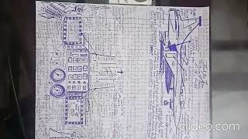](https://www.youtube.com/watch?v=-1YJN7TkHvk&authuser=0)](https://www.youtube.com/watch?v=-1YJN7TkHvk&authuser=0" \t "_blank)

[[https://ssl.gstatic.com/docs/doclist/images/mediatype/icon_2_youtube_x16.png](https://www.youtube.com/watch?v=-1YJN7TkHvk&authuser=0)](https://www.youtube.com/watch?v=-1YJN7TkHvk&authuser=0" \t "_blank)

[Preview YouTube video Lakshya Title Track - 8K/4K Music Video | Hrithik Roshan | Preity Zinta | Shankar Ehsaan Loy](https://www.youtube.com/watch?v=sSsw7QPrUk0&authuser=0" \t "_blank)

[[](https://www.youtube.com/watch?v=sSsw7QPrUk0&authuser=0)](https://www.youtube.com/watch?v=sSsw7QPrUk0&authuser=0" \t "_blank)

[[https://ssl.gstatic.com/docs/doclist/images/mediatype/icon_2_youtube_x16.png](https://www.youtube.com/watch?v=sSsw7QPrUk0&authuser=0)](https://www.youtube.com/watch?v=sSsw7QPrUk0&authuser=0" \t "_blank)

|  |  |
| --- | --- |
| https://lh3.googleusercontent.com/a/ACg8ocIi0sD_-J-LCr_R6KhD386tAqdpyOphIJbYDj5hcGANagzGUZRE=s40-p |  |

[HTTPS://ELIYASYEDALIABBASP.WIXSITE.COM/LOVE-SERVE-PROTECT](https://istheonlywayjesusc.wixsite.com/indian-origin)

[HTTPS://ISTHEONLYWAYJESUSC.WIXSITE.COM/INDIAN](https://istheonlywayjesusc.wixsite.com/indian-origin)

[HTTPS://ISTHEONLYWAYJESUSC.WIXSITE.COM/CHRISTIAN](https://istheonlywayjesusc.wixsite.com/indian-origin)

[HTTPS://ISTHEONLYWAYJESUSC.WIXSITE.COM/CAPTAIN-PAUL-ELIYA](https://istheonlywayjesusc.wixsite.com/indian-origin)

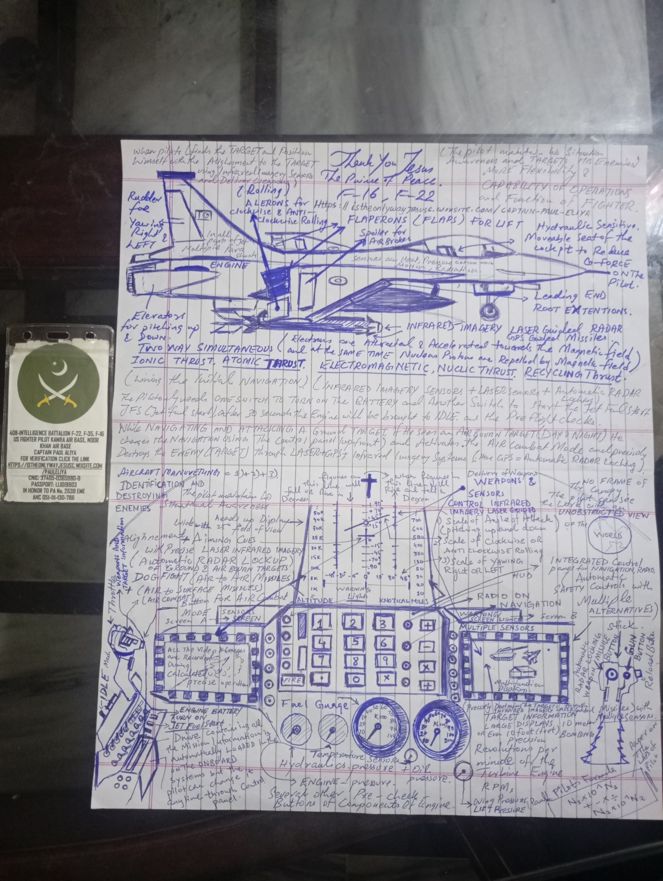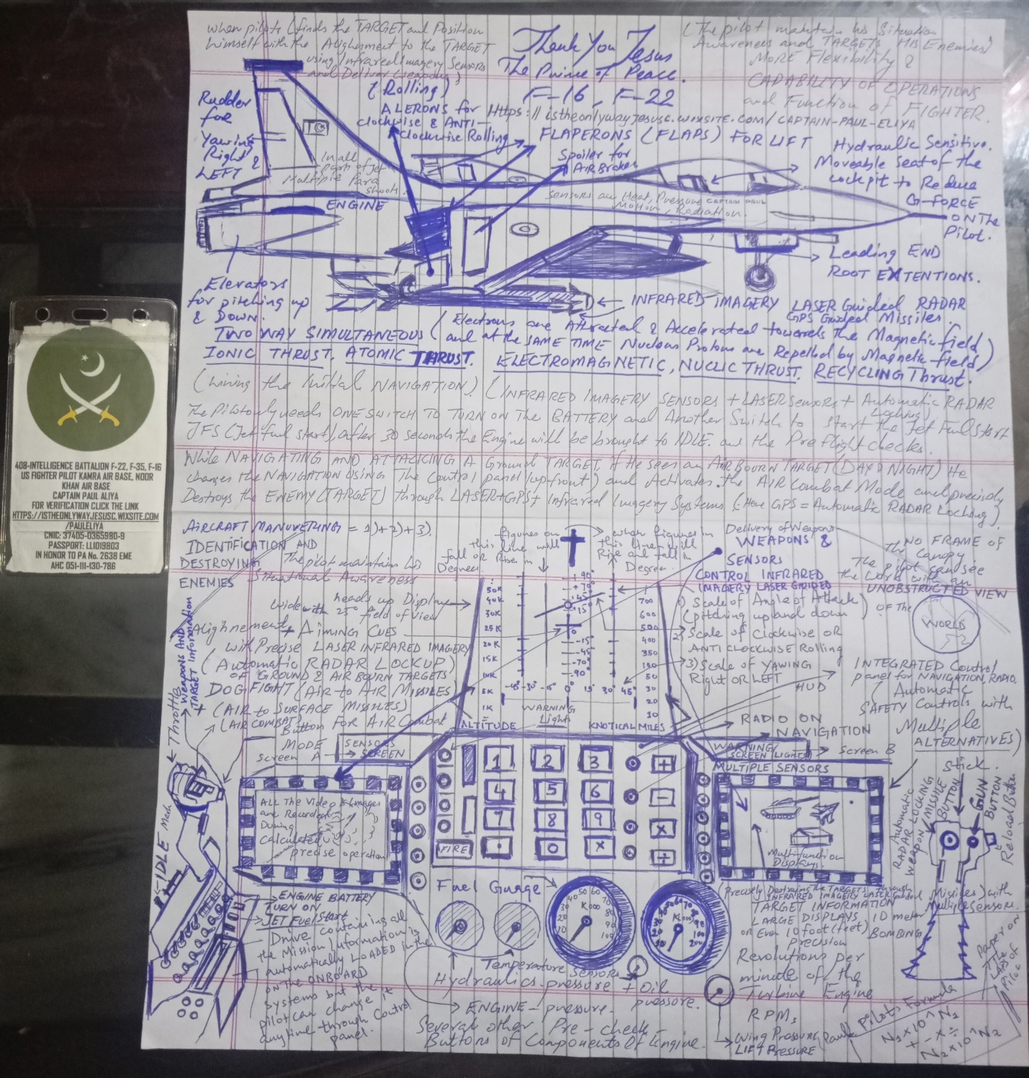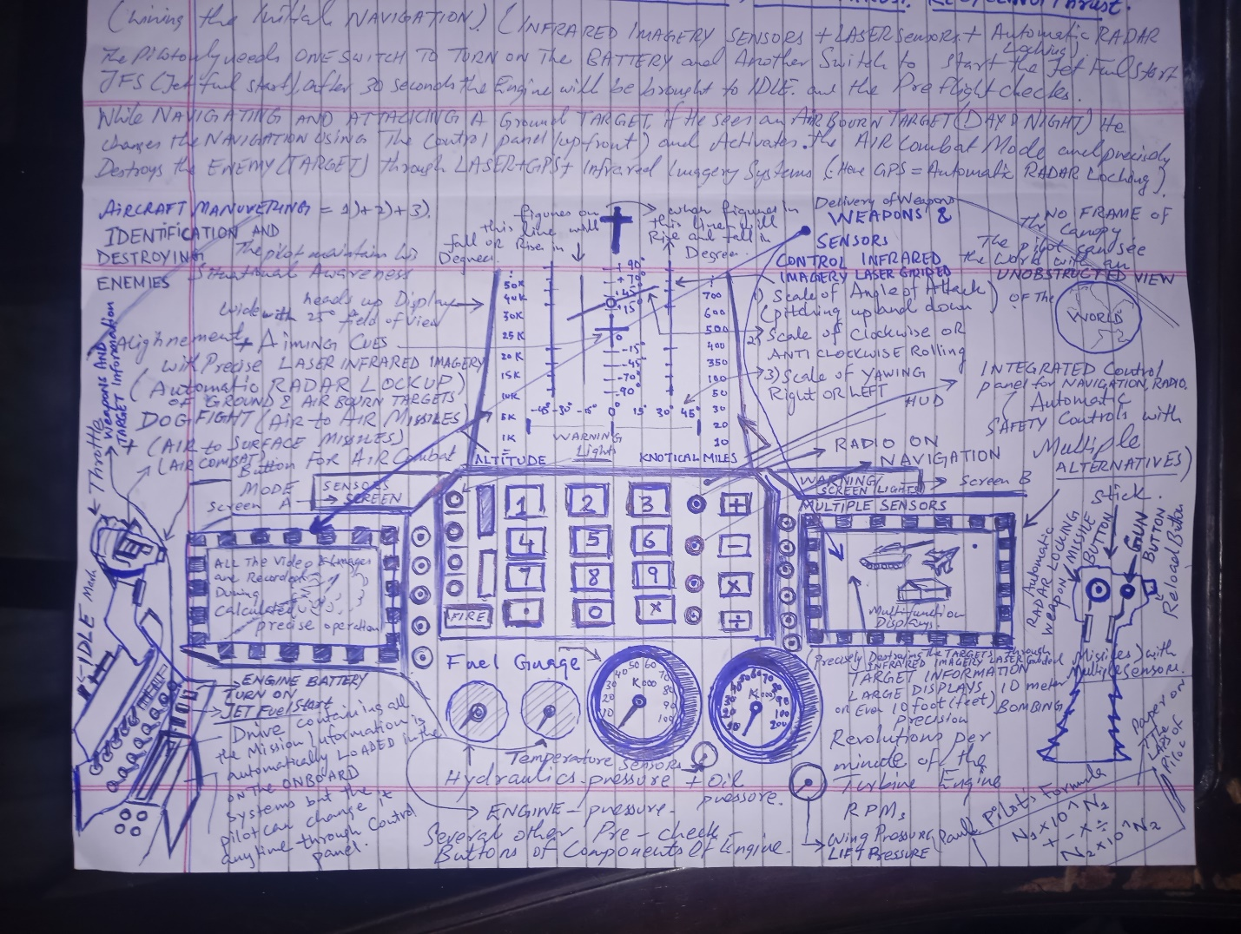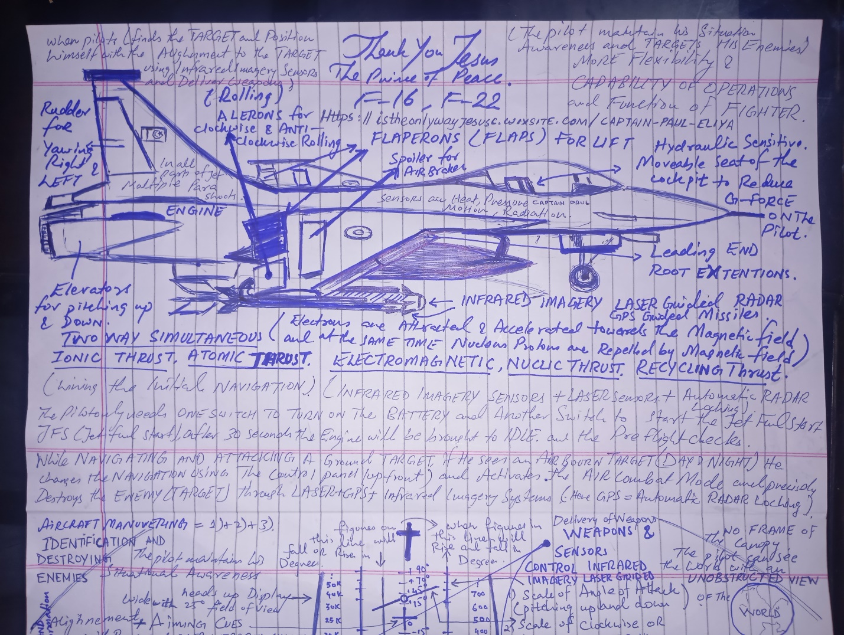

[HTTPS://ELIYASYEDALIABBASP.WIXSITE.COM/LOVE-SERVE-PROTECT](https://istheonlywayjesusc.wixsite.com/indian-origin)

[HTTPS://ISTHEONLYWAYJESUSC.WIXSITE.COM/INDIAN](https://istheonlywayjesusc.wixsite.com/indian-origin)

[HTTPS://ISTHEONLYWAYJESUSC.WIXSITE.COM/CHRISTIAN](https://istheonlywayjesusc.wixsite.com/indian-origin)

[HTTPS://ISTHEONLYWAYJESUSC.WIXSITE.COM/CAPTAIN-PAUL-ELIYA](https://istheonlywayjesusc.wixsite.com/indian-origin)

[This website was built on Wix. Create yours today.Get Started](https://www.wix.com/lpviral/enviral?utm_campaign=vir_wixad_live&adsVersion=banner_2024&orig_msid=aa99f552-cce6-4d9b-96f0-a304175f7068&orig_msid=8d816c2b-d2d1-46cb-aa6c-ef2fe309317c&adsVersion=banner_2024)





[](https://8d816c2b-d2d1-46cb-aa6c-ef2fe309317c.filesusr.com/ugd/c98d81_b3a9004329524a9f8fbb532713833645.pdf)

**408 INTELLIGENCE BATTALION PAKISTAN ARMY OFFICER 408-INTELLIGENCE BATTALION F-22, F-35, F-16 US FIGHTER PILOT KAMRA AIR BASE, NOOR**

**KHAN AIR BASE CAPTAIN PAUL ALIYAFOR VERIFICATION CLICK THE LINK**[**HTTPS://ISTHEONLYWAYJESUSC.WIXSITE.COM/PAULELIYA**](https://istheonlywayjesusc.wixsite.com/indian-origin)**IN HONOR TO PA No. 2638 EME BRIG SYED AHMED PIONEER FOUNDER OF NISHAN JEEP SITARA-E-KHIDMAT AHC 051-111-130-786**[**HTTPS://ISTHEONLYWAYJESUSC.WIXSITE.COM/PAULELIYA**](https://istheonlywayjesusc.wixsite.com/indian-origin)[**HTTPS://ISTHEONLYWAYJESUSC.WIXSITE.COM/TOPGUN**](https://istheonlywayjesusc.wixsite.com/indian-origin)[**HTTPS://ISTHEONLYWAYJESUSC.WIXSITE.COM/TOP-GUN**](https://istheonlywayjesusc.wixsite.com/indian-origin)[**HTTPS://ISTHEONLYWAYJESUSC.WIXSITE.COM/CAPTAIN-PAUL-ELIYA**](https://istheonlywayjesusc.wixsite.com/indian-origin)

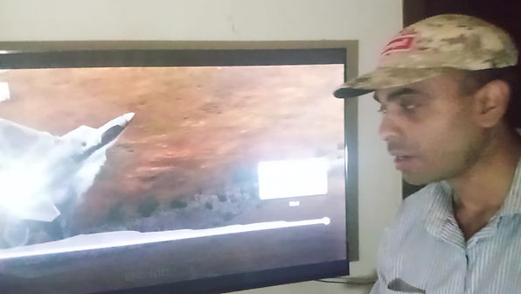

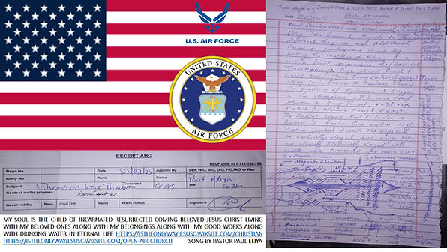

[**DOWNLOAD**](https://8d816c2b-d2d1-46cb-aa6c-ef2fe309317c.filesusr.com/ugd/c98d81_d5a1b2b2cc57432eb2cde0879ea0d574.pdf)

[OUR PERSECUTION STORY pdf](https://8d816c2b-d2d1-46cb-aa6c-ef2fe309317c.filesusr.com/ugd/c98d81_d5a1b2b2cc57432eb2cde0879ea0d574.pdf)

[OUR PERSECUTION STORY docx](https://8d816c2b-d2d1-46cb-aa6c-ef2fe309317c.filesusr.com/ugd/c98d81_b13aa2137aab4a4badedda3907937b12.docx?dn=OUR%20STORY.docx)

[MY DREAM OUR LIFE. docx](https://8d816c2b-d2d1-46cb-aa6c-ef2fe309317c.filesusr.com/ugd/c98d81_88ccb053095e4732ad0130684f14f27f.docx?dn=MY%20GOOD%20WORKS.docx)

[MY GOOD WORK.pdf](https://8d816c2b-d2d1-46cb-aa6c-ef2fe309317c.filesusr.com/ugd/c98d81_90b41e2f11c740978aeb5f11f391d61b.pdf)

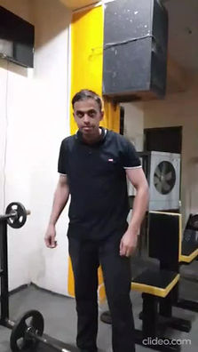

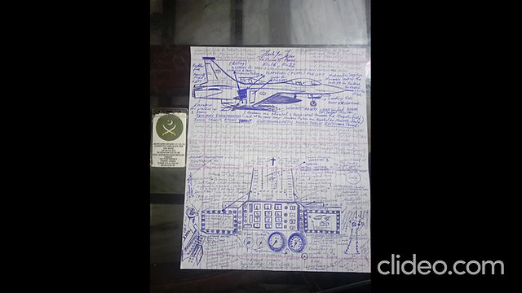

[FREE TRAINING](https://8d816c2b-d2d1-46cb-aa6c-ef2fe309317c.filesusr.com/ugd/c98d81_83cfa09ffcd94886974975d359076c8c.docx?dn=WISDOM.docx)

[PERFECT FIGHTER PILOT](https://8d816c2b-d2d1-46cb-aa6c-ef2fe309317c.filesusr.com/ugd/c98d81_f9353cfcebf54b128e3940484b05af4a.pdf)

[FREE TRAINING](https://8d816c2b-d2d1-46cb-aa6c-ef2fe309317c.filesusr.com/ugd/c98d81_83cfa09ffcd94886974975d359076c8c.docx?dn=WISDOM.docx)

[PERFECT FIGHTER PILOT](https://8d816c2b-d2d1-46cb-aa6c-ef2fe309317c.filesusr.com/ugd/c98d81_f9353cfcebf54b128e3940484b05af4a.pdf)

[[](https://8d816c2b-d2d1-46cb-aa6c-ef2fe309317c.filesusr.com/ugd/c98d81_83cfa09ffcd94886974975d359076c8c.docx?dn=WISDOM.docx)](https://8d816c2b-d2d1-46cb-aa6c-ef2fe309317c.filesusr.com/ugd/c98d81_83cfa09ffcd94886974975d359076c8c.docx?dn=WISDOM.docx" \o "WISDOM.docx" \t "_blank)

[[](https://8d816c2b-d2d1-46cb-aa6c-ef2fe309317c.filesusr.com/ugd/c98d81_f9353cfcebf54b128e3940484b05af4a.pdf)](https://8d816c2b-d2d1-46cb-aa6c-ef2fe309317c.filesusr.com/ugd/c98d81_f9353cfcebf54b128e3940484b05af4a.pdf" \o "WISDOM.pdf" \t "_blank)

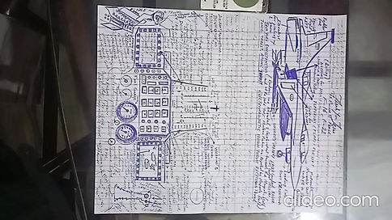

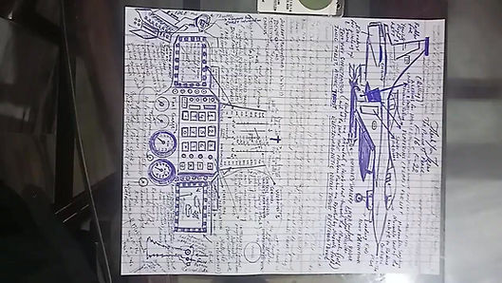

[](https://8d816c2b-d2d1-46cb-aa6c-ef2fe309317c.filesusr.com/ugd/c98d81_b3a9004329524a9f8fbb532713833645.pdf)

[HTTPS://ELIYASYEDALIABBASP.WIXSITE.COM/LOVE-SERVE-PROTECT](https://istheonlywayjesusc.wixsite.com/indian-origin)

[HTTPS://ISTHEONLYWAYJESUSC.WIXSITE.COM/INDIAN](https://istheonlywayjesusc.wixsite.com/indian-origin)

[HTTPS://ISTHEONLYWAYJESUSC.WIXSITE.COM/CHRISTIAN](https://istheonlywayjesusc.wixsite.com/indian-origin)

[HTTPS://ISTHEONLYWAYJESUSC.WIXSITE.COM/CAPTAIN-PAUL-ELIYA](https://istheonlywayjesusc.wixsite.com/indian-origin)

[This website was built on Wix. Create yours today.Get Started](https://www.wix.com/lpviral/enviral?utm_campaign=vir_wixad_live&adsVersion=banner_2024&orig_msid=aa99f552-cce6-4d9b-96f0-a304175f7068&orig_msid=2d544547-1c8d-4e83-a14e-71181c6be19a&adsVersion=banner_2024)





**408 INTELLIGENCE BATTALION PAKISTAN ARMY OFFICER 408-INTELLIGENCE BATTALION F-22, F-35, F-16 US FIGHTER PILOT KAMRA AIR BASE, NOOR**

**KHAN AIR BASE CAPTAIN PAUL ALIYA FOR VERIFICATION CLICK THE LINK**[**HTTPS://ISTHEONLYWAYJESUSC.WIXSITE.COM/PAULELIYA**](https://istheonlywayjesusc.wixsite.com/pauleliya)**IN HONOR TO PA No. 2638 EME BRIG SYED AHMED PIONEER FOUNDER OF NISHAN JEEP SITARA-E-KHIDMAT AHC 051-111-130-786**[**HTTPS://ISTHEONLYWAYJESUSC.WIXSITE.COM/PAULELIYA**](https://istheonlywayjesusc.wixsite.com/pauleliya)[**HTTPS://ISTHEONLYWAYJESUSC.WIXSITE.COM/TOPGUN**](https://istheonlywayjesusc.wixsite.com/pauleliya)[**HTTPS://ISTHEONLYWAYJESUSC.WIXSITE.COM/TOP-GUN**](https://istheonlywayjesusc.wixsite.com/pauleliya)[**HTTPS://ISTHEONLYWAYJESUSC.WIXSITE.COM/CAPTAIN-PAUL-ELIYA**](https://istheonlywayjesusc.wixsite.com/pauleliya)





[HTTPS://ELIYASYEDALIABBASP.WIXSITE.COM/LOVE-SERVE-PROTECT](https://istheonlywayjesusc.wixsite.com/pauleliya)

[HTTPS://ISTHEONLYWAYJESUSC.WIXSITE.COM/INDIAN](https://istheonlywayjesusc.wixsite.com/pauleliya)

[HTTPS://ISTHEONLYWAYJESUSC.WIXSITE.COM/CHRISTIAN](https://istheonlywayjesusc.wixsite.com/pauleliya)

[HTTPS://ISTHEONLYWAYJESUSC.WIXSITE.COM/CAPTAIN-PAUL-ELIYA](https://istheonlywayjesusc.wixsite.com/pauleliya)

[HTTPS://ISTHEONLYWAYJESUSC.WIXSITE.COM/INDIAN-ORIGIN](https://istheonlywayjesusc.wixsite.com/pauleliya)

[OUR PERSECUTION STORY pdf](https://2d544547-1c8d-4e83-a14e-71181c6be19a.filesusr.com/ugd/c98d81_d5a1b2b2cc57432eb2cde0879ea0d574.pdf)

[OUR PERSECUTION STORY docx](https://2d544547-1c8d-4e83-a14e-71181c6be19a.filesusr.com/ugd/c98d81_b13aa2137aab4a4badedda3907937b12.docx?dn=OUR%20STORY.docx)

[MY DREAM OUR LIFE. docx](https://2d544547-1c8d-4e83-a14e-71181c6be19a.filesusr.com/ugd/c98d81_88ccb053095e4732ad0130684f14f27f.docx?dn=MY%20GOOD%20WORKS.docx)

[MY GOOD WORK.pdf](https://2d544547-1c8d-4e83-a14e-71181c6be19a.filesusr.com/ugd/c98d81_90b41e2f11c740978aeb5f11f391d61b.pdf)

[**DOWNLOAD**](https://2d544547-1c8d-4e83-a14e-71181c6be19a.filesusr.com/ugd/c98d81_d5a1b2b2cc57432eb2cde0879ea0d574.pdf)





[FREE TRAINING](https://2d544547-1c8d-4e83-a14e-71181c6be19a.filesusr.com/ugd/c98d81_83cfa09ffcd94886974975d359076c8c.docx?dn=WISDOM.docx)

[PERFECT FIGHTER PILOT](https://2d544547-1c8d-4e83-a14e-71181c6be19a.filesusr.com/ugd/c98d81_f9353cfcebf54b128e3940484b05af4a.pdf)

[FREE TRAINING](https://2d544547-1c8d-4e83-a14e-71181c6be19a.filesusr.com/ugd/c98d81_83cfa09ffcd94886974975d359076c8c.docx?dn=WISDOM.docx)

[PERFECT FIGHTER PILOT](https://2d544547-1c8d-4e83-a14e-71181c6be19a.filesusr.com/ugd/c98d81_f9353cfcebf54b128e3940484b05af4a.pdf)

[[](https://2d544547-1c8d-4e83-a14e-71181c6be19a.filesusr.com/ugd/c98d81_83cfa09ffcd94886974975d359076c8c.docx?dn=WISDOM.docx)](https://2d544547-1c8d-4e83-a14e-71181c6be19a.filesusr.com/ugd/c98d81_83cfa09ffcd94886974975d359076c8c.docx?dn=WISDOM.docx" \o "WISDOM.docx" \t "_blank)

[[](https://2d544547-1c8d-4e83-a14e-71181c6be19a.filesusr.com/ugd/c98d81_f9353cfcebf54b128e3940484b05af4a.pdf)](https://2d544547-1c8d-4e83-a14e-71181c6be19a.filesusr.com/ugd/c98d81_f9353cfcebf54b128e3940484b05af4a.pdf" \o "WISDOM.pdf" \t "_blank)



